Nama : Elizabeth Laura Helvin  
NIM : 2702255142

Tugas WebProg

https://github.com/ElizabethLauraHelvin/Edufun-2702255142

Homepage

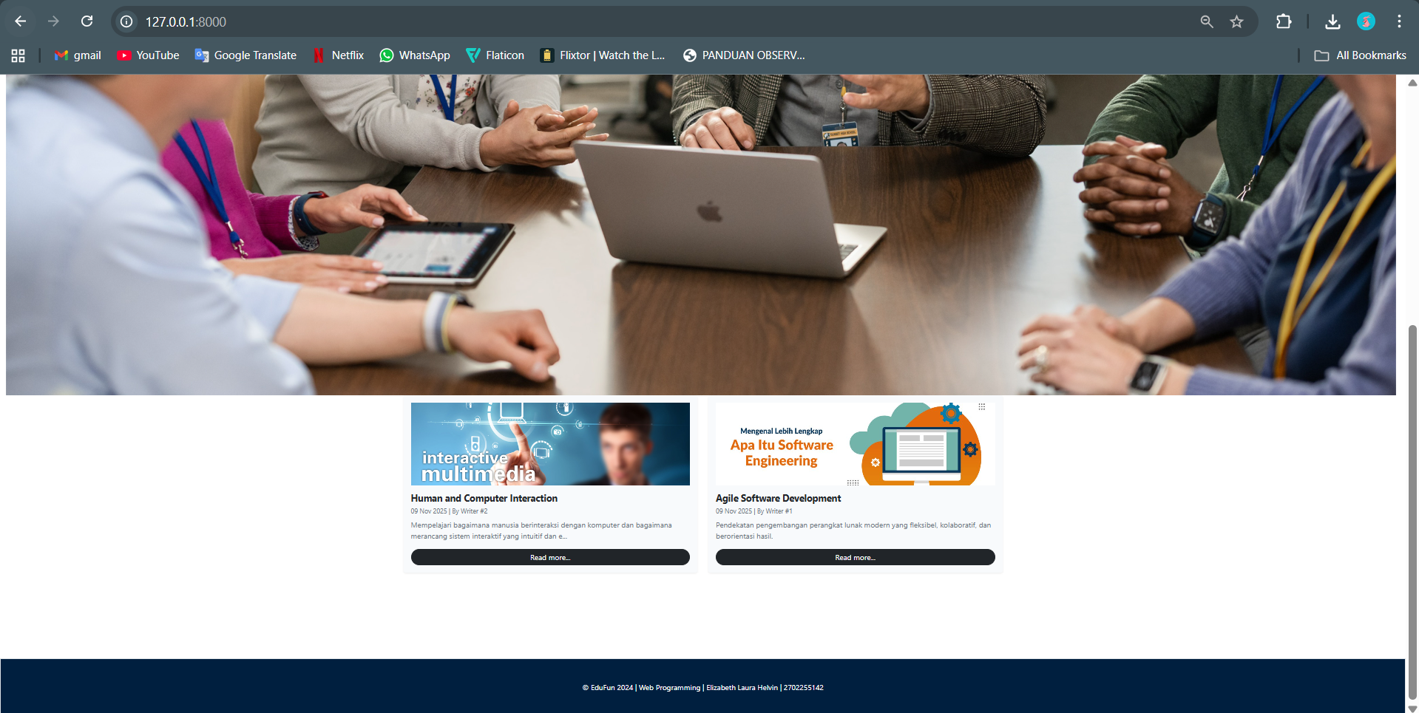

Category – Interactive MultiMedia

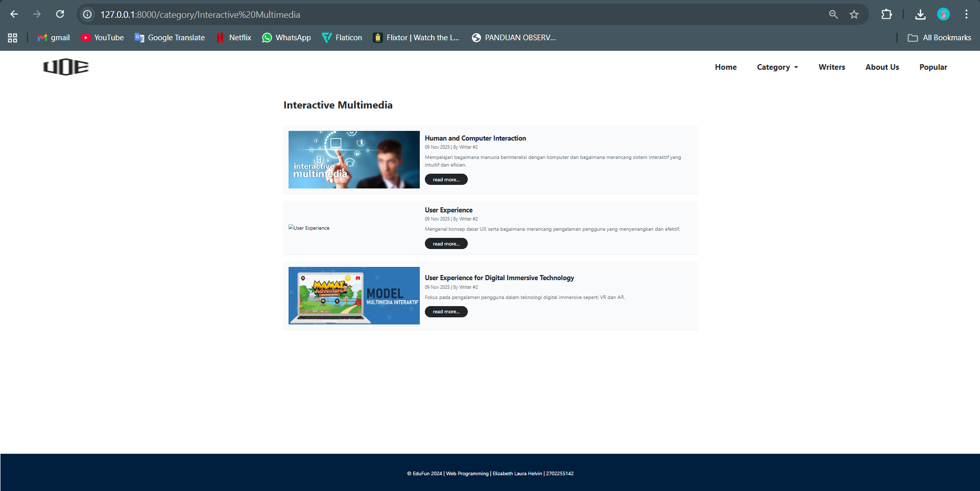

Category – Software Engineering

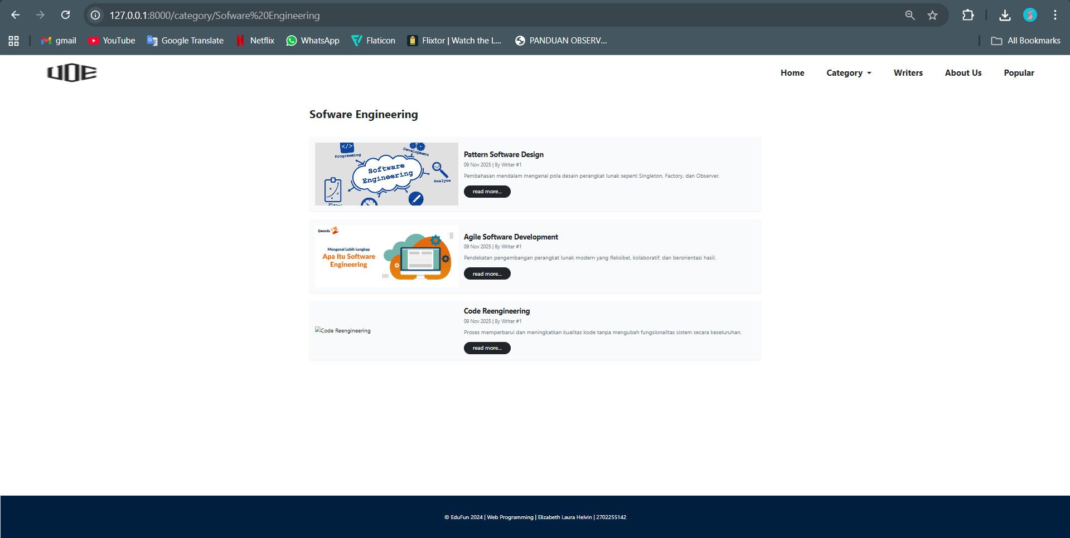

Writers

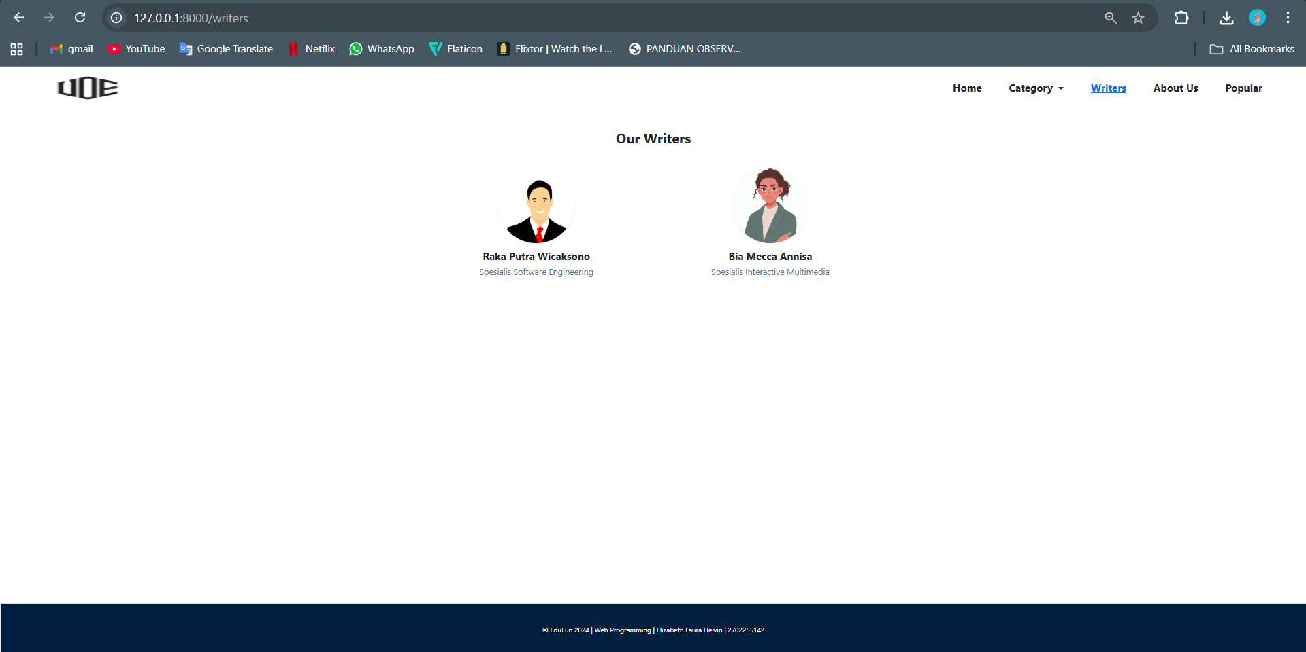

About Us

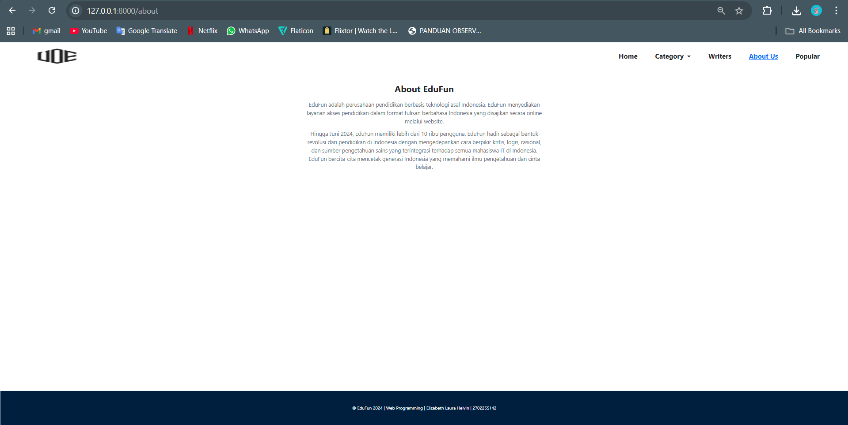

Jalankan:

* Buat database dengan nama ‘edufun_db’
* php artisan migrate
* jalankan dengan ‘php artisan serve’